Detailed Breakdown of Propeller Classification:
- Pitch: theoretical distance a propellor moves forward in one revolution
  - TYPES:
    - Fixed-Pitch Propeller (FPP): blade angles permanently set in fixed position
    - Controllable-Pitch Propeller (CPP): Allows blades to rotate around their axis adjusting the pitch. Allows change in speed and direction without reversing the motors.
    - Folding Propeller: when motors not running, blades fold backward to reduce drag
    - Feathering Propellor: Blades rotate to align with the flow of water, even less drag than a folding propeller.
- Blade Number: affects speed, thrust and vibration:
  - TYPES:
    - Two-Bladed: high efficient, but more vibration
    - Three-Bladed: balance of speed and efficiency
    - Four-Bladed: stronger acceleration and better grip, but top speed decreased
    - 5 or More: very smooth ,quiet, excellent thrust.
  - How many propeller blades do you need?
  - Evolution of Propellers and Thrust Equation
- Blade Shape: different needed for different performance needs
  - TYPES:
    - Conventional: rounded blades
    - Cupped: small, curved lip on blade’s trailing edge to increase thrust and reduce slippage
    - Cleaver: high speed design, straight blades for surface piercing applications
    - Weedless: high skew to shed weeds and debris in contaminated/dirty water
- Material: effective durability, cost, performance. Specific heats should be considered so that the propellers do not deform.
  - TYPES:
    - Aluminum: common, affordable, lightweight but slightly less durable than other options
    - Stainless Steel: more durable and stronger than aluminum, can use thinner blades
    - Bronze: strong, corrosion resistant, rigid.

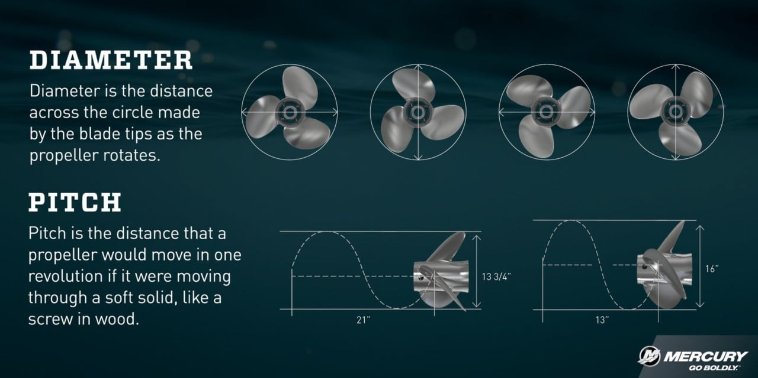

Common Selection Data:
- Larger diameter = lower RPM = more thrust per watt
- More blades = smoother thrust and less cavitation but higher drag
- Higher pitch = higher speed for a given RPM but might cause motor overload
- Shrouded propellers give higher static thrust for same wattage

Information Needed from the ROV:
- Pick target thrust per thruster based on vehicle mass & tasks
  - Propeller performance charts provided to map thrust -> power
- Propellor needs to match to motor (in voltage, kV, and torque)

Notes for designing a propellor:
- NACA 66 (mod) [General marine use, industry standard]
- DTMB 4119 [submarine propellers, US Navy Standard]
- Eppler 800 series [small scale hydrofoils, smooth pressure distribution]
- YS-900 series [advanced submarine/torpedo]

For our smaller application, the best choice would most likely be the Eppler 800 series

Through Picking a Cross Section, Some design points are set in stone, while others are variable by design:
- Static Parameters (defined by the Hydrofoil)
  - Camber line shape (determines pressure distribution and lift curve)
  - Maximum Camber (%)
  - Thickness Distribution
  - Leading Edge radius

- Adjustable Design Parameters:
  - Number of Blades (fewer blades = higher efficiency, more blades = smoother and quite flow but more drag)
  - Diameter (bigger diameter = more thrust)
  - Pitch/Pitch Distribution (ratio of advance per revolution)
  - Blade Area Ratio
  - Radial Hydrofoil Variation (can mix foil sections along the span)
  - Hub Ratio (Hub Diameter)
  - Skew and Rake (3D shaping of blades)

Reynold’s Number Calculation
$Re = \frac{ ρVL}{μ} = \frac{(1000kg/m^{3})(10m/s)(0.05m)}{(10^{-3}kg/m*s)} = 500,000$
Calculations using:
- Density of water
- Viscosity of Water
- Top expected velocity
- Maximum expected length from leading to trailing edge of propeller cross section

ROV Design and Customization

Research Papers:
Aspects of Propeller Developments for a Submarine, By Anderson
Anderson’s Design Spiral for Submarine Propellers:
- Start Propeller Design
- Hydrodynamic
- Hydroacoustic
- Structural Analysis
- Feed-Back Analysis
- Degree of Performance
- Simulation Modeling
- Solution

Air and Hydro foil resources
http://airfoiltools.com/
UIUC Airfoil Data Site

Material Data

